Array Extension – 3D Array

Table of contents

3D array concept 1

Content type 1

Creating an array 1

Actions 1

Set size 1

Set a value 1

Set a text 1

Insert a value 1

Conditions 1

Expressions 1

Events 1

The array extension allows you to use 3 dimensional arrays. Note that you can use them as 1 or 2 dimensional arrays if you set one or two dimensions’ size to 1.

# 3D array concept

A 3-dimensional (3D) array can be considered as a cube containing a lot of smaller cubes, each owning a value. An element can be spotted thanks to 3 indices which represent each the element’s position in each of the 3 dimensions.

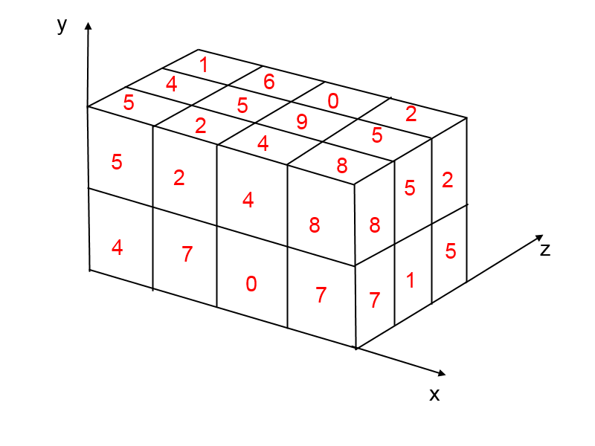

Figure 1 – A 3D array of size 4; 2; 3

This example shows a 3D array of size 4; 2; 3 (respectively the width, the height and the depth of the array). The 3 axis represent the 3 dimensions of the array. The element containing “9” is located at the position 2; 1; 1 because it is in the 3rd row on X, the 2nd on Y and Z **(the indices are zero-based, they begin at 0, not at 1)**.

This array of size 4; 2; 3 can store $4×2×3=24$ elements all reachable thanks to 3 indices.

By setting the depth to 1, we obtain a 2D array. If you also set the height to 1, the array will have only 1 dimension.

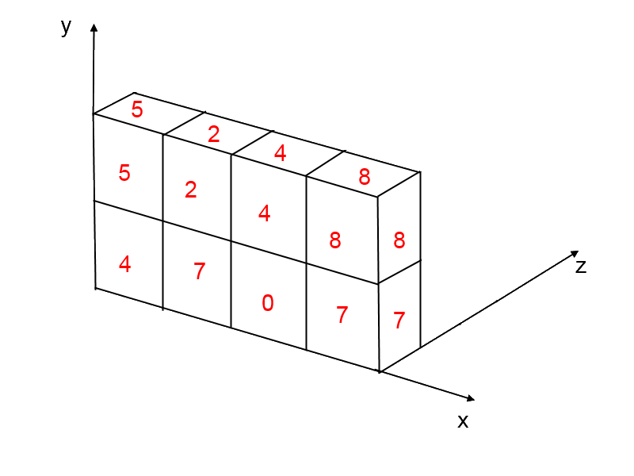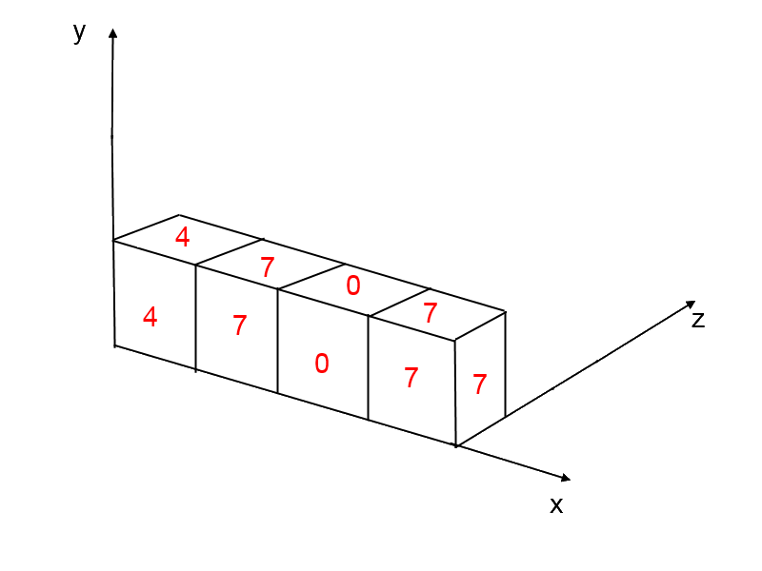

Figure 2 – A 2D array (left) and a 1D array (right)

# Content type

Each element of an array can contain either a number or a text. The arrays can own cells containing numbers and cells containing texts.

# Creating an array

If you use an action, a condition or an expression related to an array, the array will be created automatically. But, as an array doesn't resize automatically, it will be created with a size of 0; 0; 0. So, it will be empty. That’s why you need to call the action “Set size” in order to really create an array with an initial size.

# Actions

All actions concerning 3D arrays are available in “3D Array” category.

## Set size

**This actions change the size of a 3D array. It is needed to create an array because the action « Set a number/text » can’t change the array’s size (if the index is out of the array, nothing happens).**

**Array name  
Description: *Name of the array to be changed*  
Type: *Text expression***

**Width  
Description: *The future width of the array (size on X)*   
Type: *Numerical expression (integer)***

**Height  
Description: *The future height of the array (size on Y)*   
Type: *Numerical expression (integer)***

**Depth  
Description: *The future depth of the array (size on Z)*   
Type: *Numerical expression (integer)***

## Set a value

**This action set a value as a number in an element of an array. Note: if you try to set a value out of the array (one of the indices is too high), nothing happens, the array is not resized (see** Set size **to change the array’s size).**

**Array name  
Description: *Name of the array to be changed*  
Type: *Text expression***

**X index  
Description: *The element’s position on X axis*   
Type: *Numerical expression (integer)***

**Y index  
Description: *The element’s position on Y axis*  
Type: *Numerical expression (integer)***

**Z index  
Description: *The element’s position on Z axis*  
Type: *Numerical expression (integer)***

**Modification sign  
Description: *Modification’s type (affectation, addition, subtraction, multiplication, division with the old value of the element)*   
Type: *Modification sign***

**Value  
Description: *The value to be set into the element (or to be added, subtracted … depending on the modification sign)*  
Type: *Numerical expression***

## Set a text

**This action set a text in an element of an array. Note: if you try to set a value out of the array (one of the indices is too high), nothing happens, the array is not resized (see** Set size **to change the array’s size).**

**Array name  
Description: *Name of the array to be changed*  
Type: *Text expression***

**X index  
Description: *The element’s position on X axis*   
Type: *Numerical expression (integer)***

**Y index  
Description: *The element’s position on Y axis*  
Type: *Numerical expression (integer)***

**Z index  
Description: *The element’s position on Z axis*  
Type: *Numerical expression (integer)***

**Modification sign  
Description: *Modification’s type (affectation, addition with the old text of the element)*   
Type: *Modification sign***

**Text  
Description: *The text to be set into the element (or to be added to the old text, depending on the modification sign)*  
Type: *Text expression***

## Insert a value

**This action add a value at an index of a dimension (X, Y or Z axis). The next elements are moved to the next index (+1 to their index) on the axis. In a 1D array, the action adds one element in the array. In a 2D array, it adds a row in the chosen dimension. Finally, in a 3D array, it adds a 2D plane in the chosen dimension.**

**There is some examples of this action:**

* **1 dimension : Insert a value at the index 2 on « X » :**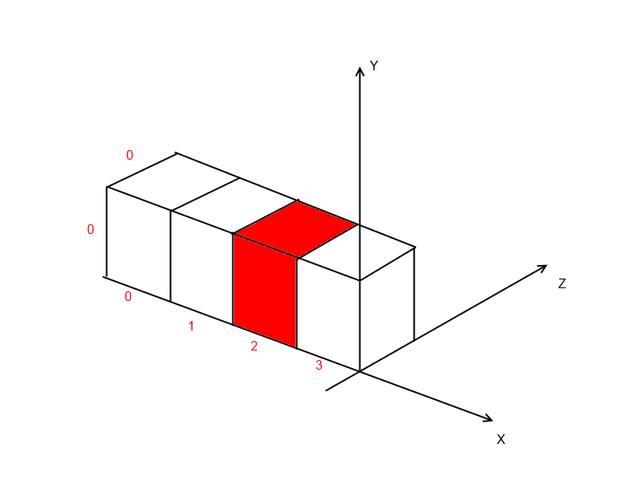
* **2 dimensions : Insert a value at the index 1 on « Y » :**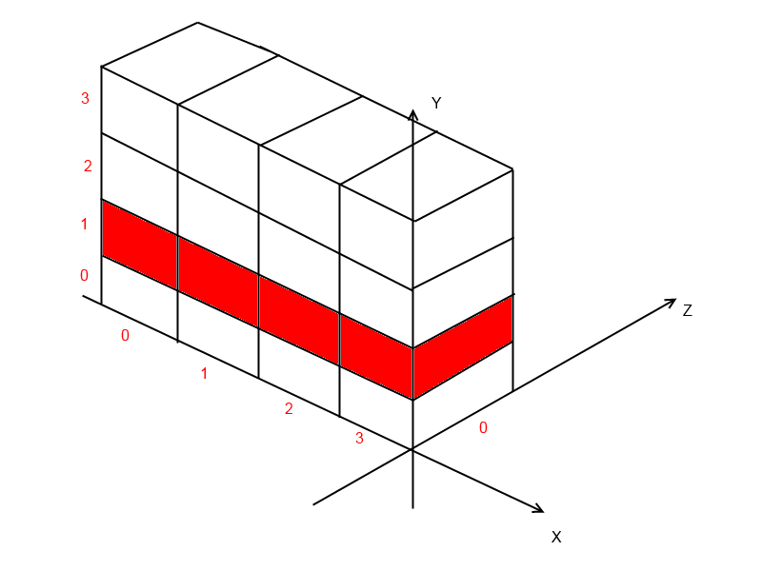
* **3 dimensions : Insert a value at the index « 2 » on « X » :**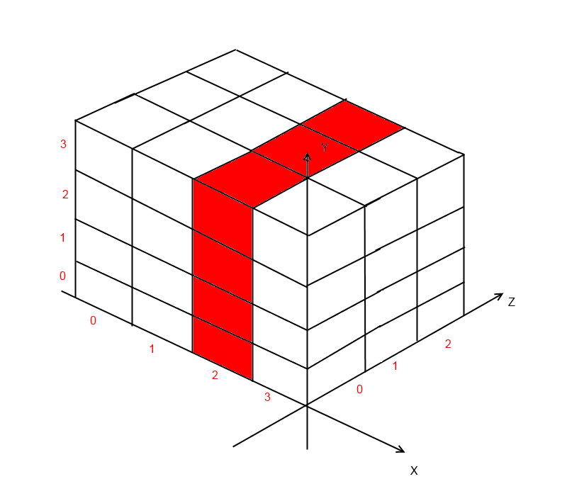

**Array name  
Description: *Name of the array to be changed*  
Type: *Text expression***

**Dimension  
Description: *Dimension where the action had to add the element(s)*   
Type: *Text expression: only "X", "Y" or "Z"***

**Index  
Description: *Index (position) where the action had to add the element(s)*   
Type: *Numerical expression (integer)***

**Value  
Description: *The value to be added (all the elements created by this action will have this value)*   
Type: *Numerical expression***

# Conditions

All conditions concerning 3D arrays are available in “3D Array” category.

# Expressions

All expressions concerning the 3D arrays are available in “3D Array” category (in the right part of the expression editor).

# Events